Get Connected
Tools for PTA Child Advocates
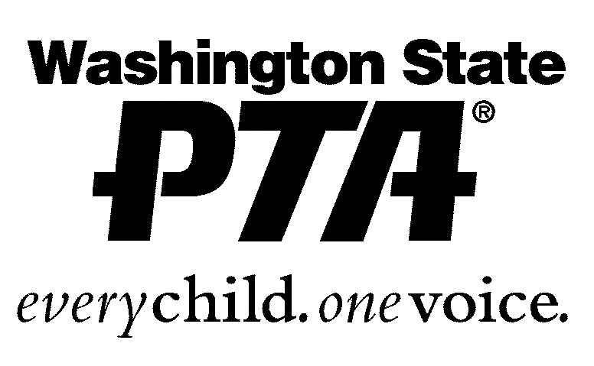
The WSPTA is the largest grassroots child advocacy organization in Washington State.
We strongly encourage and request your participation in the valuable advocacy work the WSPTA does to enhance the lives of children.

Sign up for one or all of the following opportunities designed to connect you with your WSPTA colleagues and the latest legislative news and events, by putting an “x” in the box beside each group you wish to join, and filling out the form at the bottom. Send the form via email to adminstaff@wastatepta.org

Grassroots Connection
Yes |  | The Grassroots Connection is a one-way electronic update sent weekly when the legislature is in session. It will provide you with timely, pertinent public policy information on issues affecting children and youth. (Less frequent emails will be sent when the legislature is not in session to keep you informed about opportunities for advocacy year round.)

Legislative Contact Team: ***New focus –“Critical to our efforts!”***
Yes |  | Sign up to be contacted during legislative session, and agree to make a personal phone call or visit to your Senator or Representative. You will be contacted personally and asked to request specific support on bills, public hearing of a bill or other types of Legislative activity.

Legislative Action Alerts
Yes |  | This is a one-way electronic communication alerting you to fast-breaking happenings in Olympia and requesting you to call, email, or write a letter to your legislators on a specific issue. The Action Alerts are generated by staff and sent out during legislative sessions. They are structured with background, requested action, and a brief message for you to use as a template.

Legislative Listserv
Yes (Choose a format) | Real Time Format |  | This is a two-way listserv used by members to discuss advocacy topics impacting children and youth that are relevant to the mission of the WSPTA.
 | Daily Digest Format

Please fill in the following information:
Name: |  | Local PTA Unit:
Phone #: |  | Email:
Legislative District or Zip Code:

